
assignment 1-multimeter
Done by R Dheeksha- Roll No:250861


TASK 4.1: VOLTAGE DIVIDER

OBJECTIVE
The objective of a voltage divider is to obtain a fraction of a given input voltage using in most cases two resistors connected in series (capacitors and inductors can also be used for the same-but resistors are the most common)
There are multiple different things for which voltage dividers are used for, such as creating ohmmeters, signalling, sensor interfacing etc.

THEORY
A voltage divider is a simple resistive circuit that converts a higher voltage into a lower voltage using two resistors connected in series across a voltage source

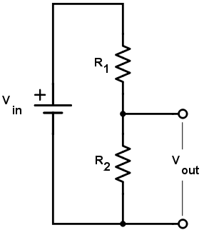
Vout=Vin*(R₂)/(R₁+ R₂)

TINKERCAD CIRCUIT
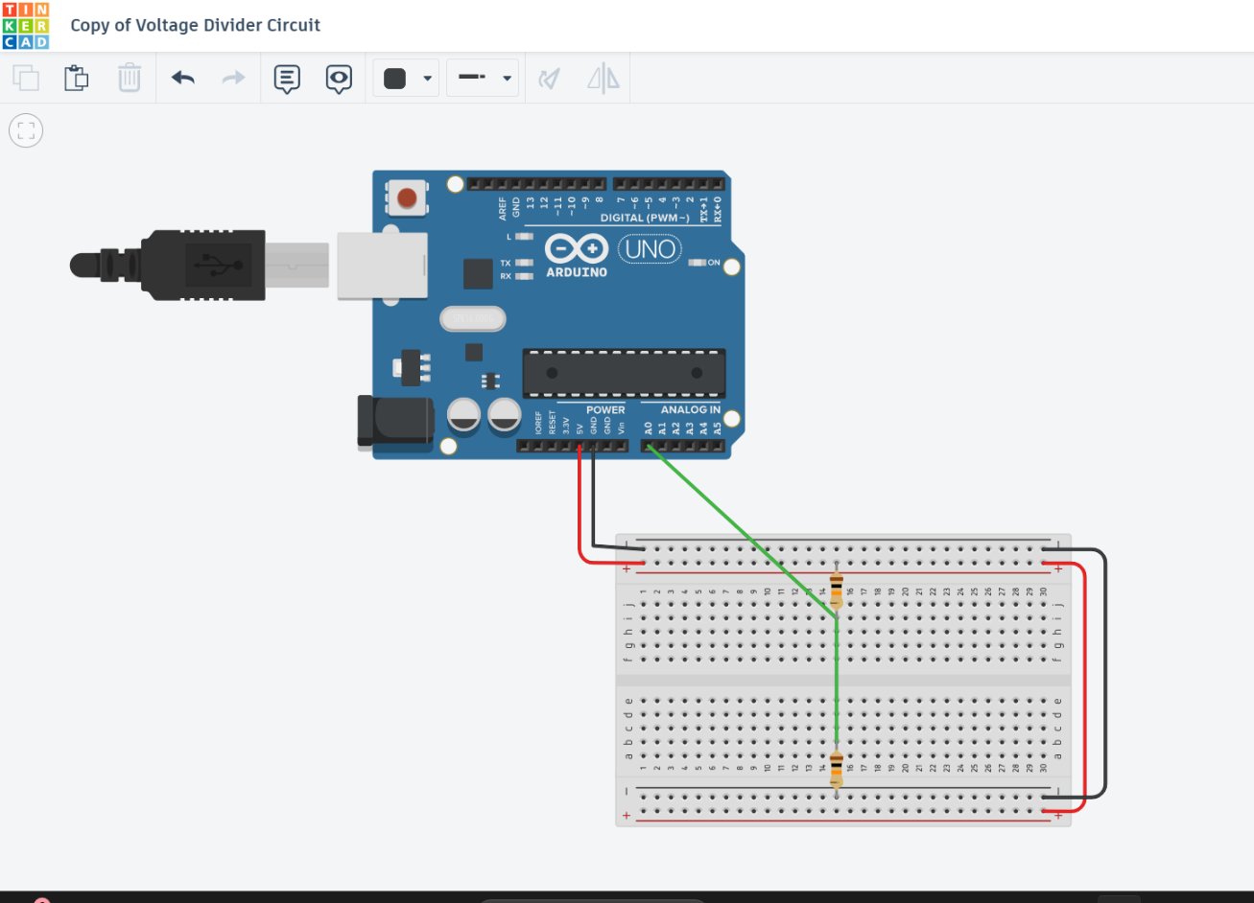
TINKERCAD CODE
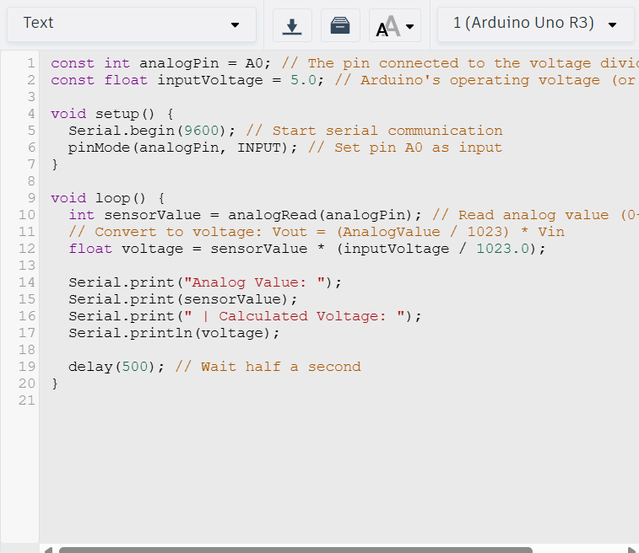
EXPLAINATION:
As we are trying to simulate what happens inside a digital multimeter, we have to connect to the serial monitor to print out the necessary output. This is followed by setting up of input pin.
In void loop() the output value is read and converted to voltage using adc conversion and printed

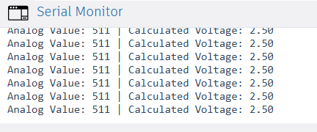
OUTPUT
CASE 1:
R1= 10k ohms
R2=10k ohms
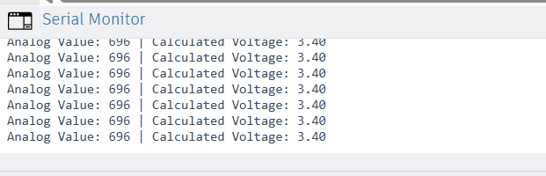
CASE 2:
R1= 4.7k ohms
R2=10k ohms

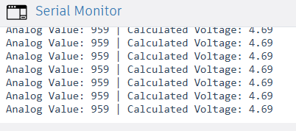
CASE 3:
R1= 1k ohms
R2=15k ohms

R1 | R2 | THEORITICAL  VOLTAGE(V) | MEASURED  VOLTAGE(V) | ANALOG  VALUE
10k ohms | 10k ohms | 2.5 | 2.5 | 511
4.7k ohms | 10k ohms | 3.401 | 3.40 | 696
1k ohms | 15k ohms | 4.688 | 4.69 | 959

POSSIBLE ERRORS (Reasons for differences in theory and measured voltage:
- ADC Quantization Error: it causes rounding errors of approximately ±½ LSB.
- Input voltage may vary: there are variations observed, no voltage can be very uniform
- Noise: noise creeps in and causes fluctuations in ADC Readings
LIMITATIONS
- Temperature: Resistance is affected by temperature and thus voltage readings are affected
- Fixed voltage range: It can only measure limited amount of voltage
ENGINEERINGS INSIGHTS: Thus, we can simulate and understand the working of a digital multimeter
CONCLUSION:
By interfacing the midpoint of the divider with the Arduino analog input, the voltage divider experiment illustrated how voltage measurement is performed internally in a digital multimeter By interfacing the midpoint of the divider with the Arduino analog input, the experiment illustrated how voltage measurement is performed internally in a digital multimeter Through this experiment, an understanding was gained of practical factors affecting voltage measurement, such as ADC resolution, reference voltage accuracy, resistor tolerance, noise, and loading effects. Overall, the experiment provided clear insight into the fundamental principles and limitations involved in real-world voltage measurement systems

TASK 4.2B Capacitance Measurement Using RC Time Constant
INTRODUCTION:
To measure capacitance, An Arduino is used to charge an unknown capacitor through a known resistor and measure the time required for the capacitor voltage to reach a specific value. By using the known relationship between resistance, capacitance, and charging time, the unknown capacitance can be calculated
OBJECTIVE:
The objective is to simulate a simple capacitance meter using an RC charging circuit. The Arduino should charge a capacitor and measure how long it takes to reach approximately 63% of the supply voltage. This helps in understanding the working of a digital multimeter.
THEORY:
Vc is the voltage across capacitor at any given point of time. The product $RC$is known as the time constant $τ$of the circuit. At time $τ=RC$, the capacitor voltage reaches approximately 63% of the supply voltage. The 63% level is significant because it occurs exactly at one time constant, making it accurate reference for calculating capacitance V_{C}​(t) = V₀(1−e^{−t/RC}); $τ$=RC
At time=$τ$, V=0.63*V_{o}
TINKERCAD CIRCUIT:
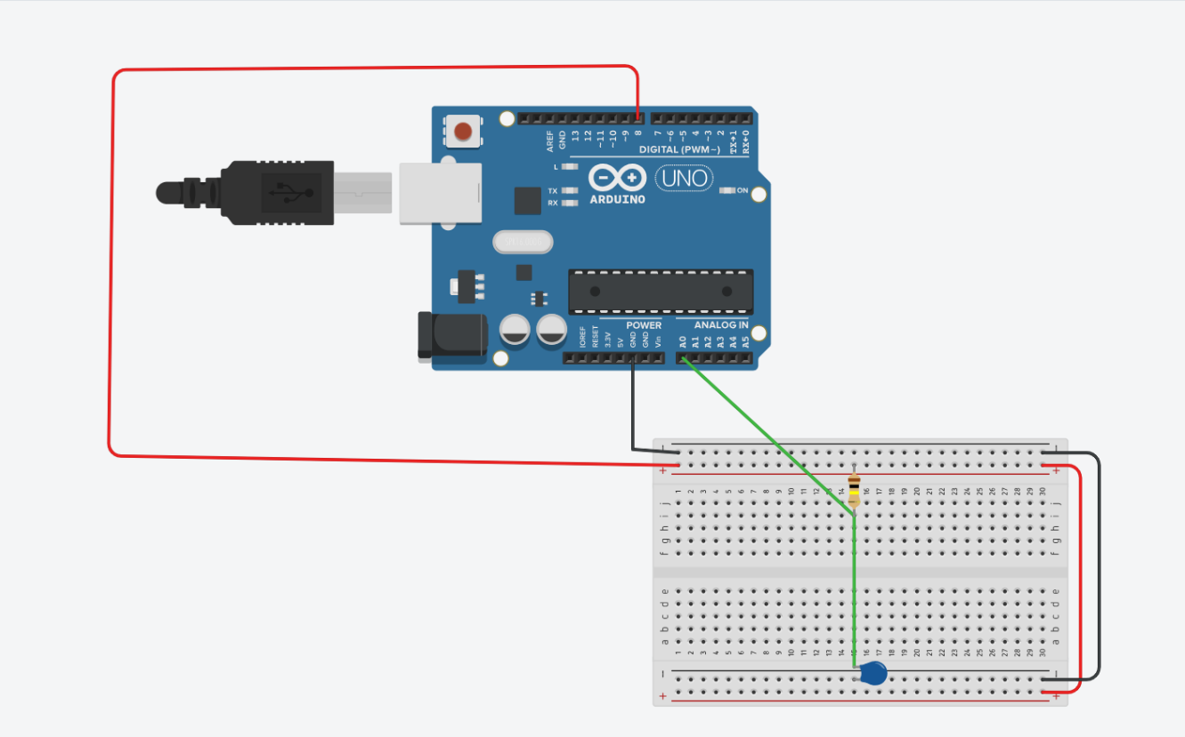
TINKERCAD CODE:
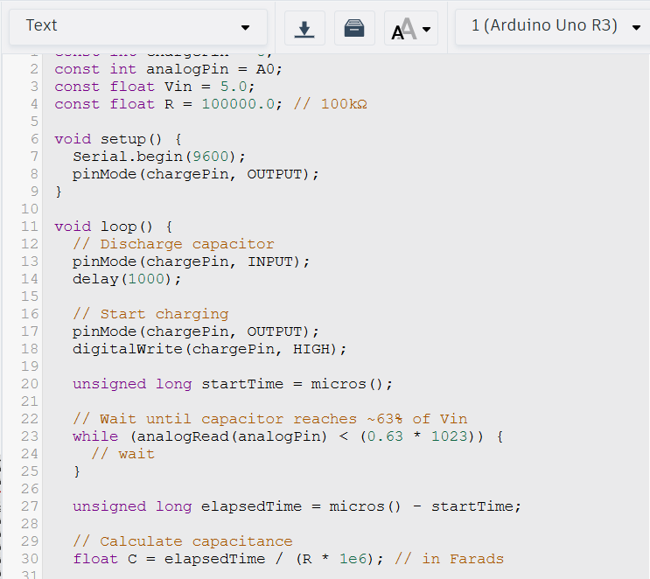

CODE EXPLAINATION:
As we are trying to simulate what happens inside a digital multimeter, we have to connect to the serial monitor to print out the necessary output. This is followed by setting up of input pin.
In void loop() the output value is read and converted to voltage using adc conversion ,we check when voltage across capacitor reaches 63% of 5V, at this point of time C is calculated using $τ$=RC

OUTPUT:
CASE 1:
C=5 micro farad
R=100k ohms
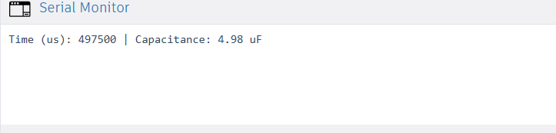

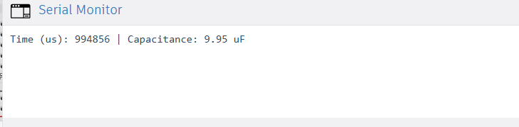
CASE 2:
C=10 micro farad
R=100k ohms
CASE 3:
C=100 micro farad
R=100k ohms
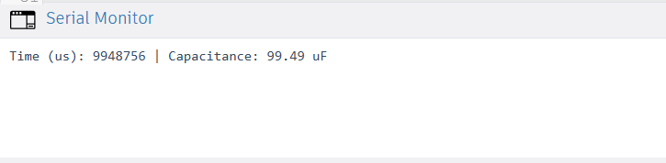

RESISTANCE  (ohms) | ACTUAL  CAPACITANCE  (micro farad) | MEASURED  CAPACITANCE  (micro farad) | MEASURED  TIME  (micro seconds) | EXPECTED TIME  (micro seconds)
100k | 5 | 4.98 | 497500 | 500000
100k | 10 | 9.95 | 994856 | 1000000
100k | 100 | 99.49 | 9948756 | 10000000

POSSIBLE ERRORS
- Electrical noise, breadboard contacts, and supply fluctuations cause variation in analog readings.
- Arduino’s 10-bit ADC limits voltage resolution, leading to uncertainty in detecting the exact 63% voltage level.
- The known resistor and the capacitor have tolerance (±1% to ±20%), causing deviation in the calculated capacitance

LIMITATIONS
- Very small capacitors charge too quickly, making accurate timing difficult
- Errors in supply voltage directly affect the 63% threshold detection

ENGINEERING INSIGHTS: Thus, we can simulate and understand the working of a digital multimeter

CONCLUSION
This experiment successfully demonstrated the measurement of an unknown capacitance using an RC charging circuit and an Arduino. The experiment reinforced key concepts such as exponential capacitor charging, time constants, ADC-based voltage measurement, and the practical limitations of digital measurements.
Learning outcomes include understanding the working principle of a capacitance meter, the role of resistor–capacitor selection, and the effects of ADC resolution, noise, and component tolerance on measurement accuracy.

TASK 4.2 C: OHMMETER
INTRODUCTION: In this experiment, a basic ohmmeter is simulated in Tinkercad using an Arduino and a fixed reference resistor. The unknown resistor is connected in a voltage divider configuration with the known resistor. By measuring the voltage at the divider junction using the Arduino’s ADC, the unknown resistance is calculated mathematically
OBJECTIVE
The objective of a voltage divider is to obtain a fraction of a given input voltage using in most cases two resistors connected in series. Using that fraction, value of R₂ can be determined, thereby voltage dividers can function as ohmmeters
THEORY
A voltage divider is a simple resistive circuit that converts a higher voltage into a lower voltage using two resistors connected in series across a voltage source. Using that lower voltage value of R₂ can be found


Vout=Vin*(R₂)/(R₁+ R₂)

R2=Vout*R1/(Vin-Vout)

TINKERCAD CIRCUIT
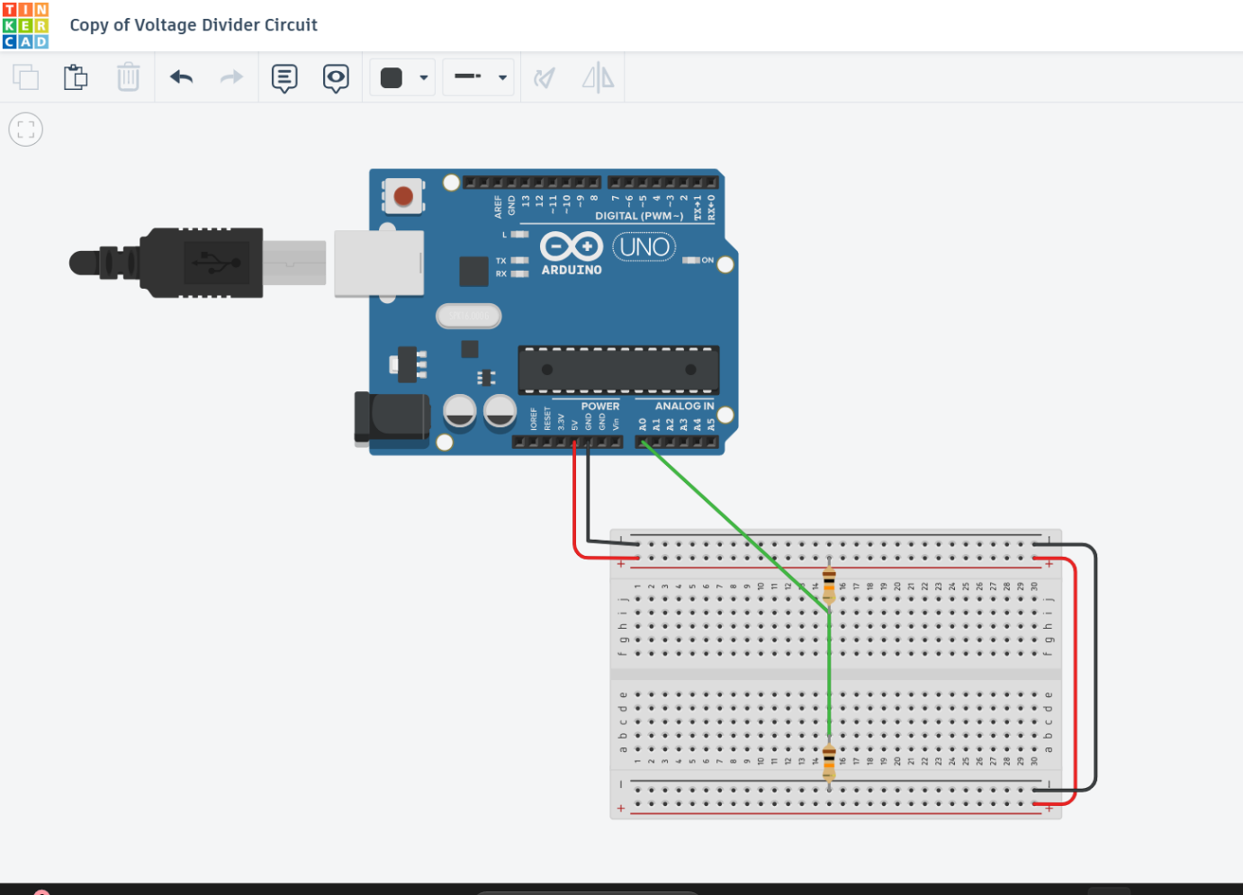TINKERCAD CODE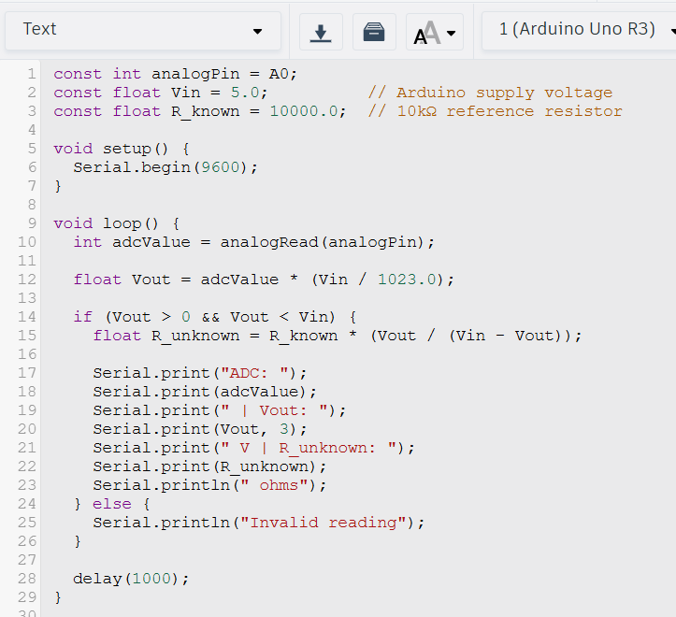
EXPLANATION
As we are trying to simulate what happens inside a digital multimeter, we have to connect to the serial monitor to print out the necessary output. This is followed by setting up of input pin.
In void loop() the output value is read and converted to voltage using adc conversion . Using this value of R2 can be found and thus the code gives usthe value of the unknown resistance.
OUTPUT
CASE 1
R_unknown=10k ohms
R_known= 10k ohms

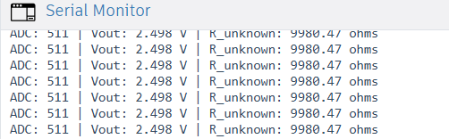
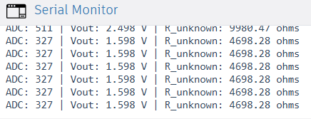
CASE 2
R_unknown=4.7k ohms
R_known= 10k ohms

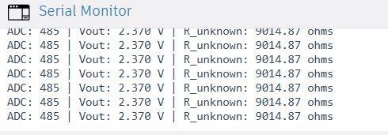
CASE 3
R_unknown=9k ohms
R_known= 10k ohms

Vout (V) | R_known ohms | R_unknown  Calculated ohms | R_unknown measured  ohms
2.498 | 10k | 10k | 9980.47
1.598 | 10k | 4.7k | 4698.28
2.370 | 10k | 9k | 9014.87

POSSIBLE ERRORS
- The Arduino’s 10-bit ADC limits voltage resolution, leading to quantization error in resistance calculation
- Inaccuracy or fluctuation in the 5 V supply directly affects the computed resistance
- Breadboard connections, wiring, and electrical noise introduce small measurement variation
LIMITATIONS
- Accurate measurement is restricted to resistor values near the reference resistor value.
- Resistance changes with temperature leading to inaccuracies in measurement

ENGINEERING INSIGHTS: Thus, we can simulate and understand the working of a digital multimeter

CONCLUSION: The Arduino-based ohmmeter simulation successfully demonstrated the measurement of an unknown resistance using a voltage divider and a fixed reference resistor. The experiment highlighted the practical application of Ohm’s law, ADC-based voltage measurement, and computational techniques used in digital instruments.

